**Project Design Phase**

**Solution Architecture**

|  |  |
| --- | --- |
| Date | 27 – June-2025 |
| Team ID | LTVIP2025TMID30752 |
| Project Name | Sustainable Smart City Assistant Using IBM Granite LLM |
| Maximum Marks | 4 Marks |

**Solution Architecture:**

Solution architecture in the context of the Sustainable Smart City Assistant project defines the integrated framework of tools, technologies, and components that enable the application to deliver smart governance, sustainability forecasting, citizen engagement, and eco-awareness through AI-driven services.

It outlines how IBM WatsonX Granite LLM, Pinecone, Streamlit, and machine learning models work together to solve real-world urban challenges such as:

* Interpreting complex policy documents
* Forecasting key sustainability KPIs
* Detecting anomalies in city resource usage
* Providing intelligent, contextual chat assistance
* Collecting and analyzing citizen feedback
* Promoting environmental behavior change via eco tips

**Example - Solution Architecture Diagram:**

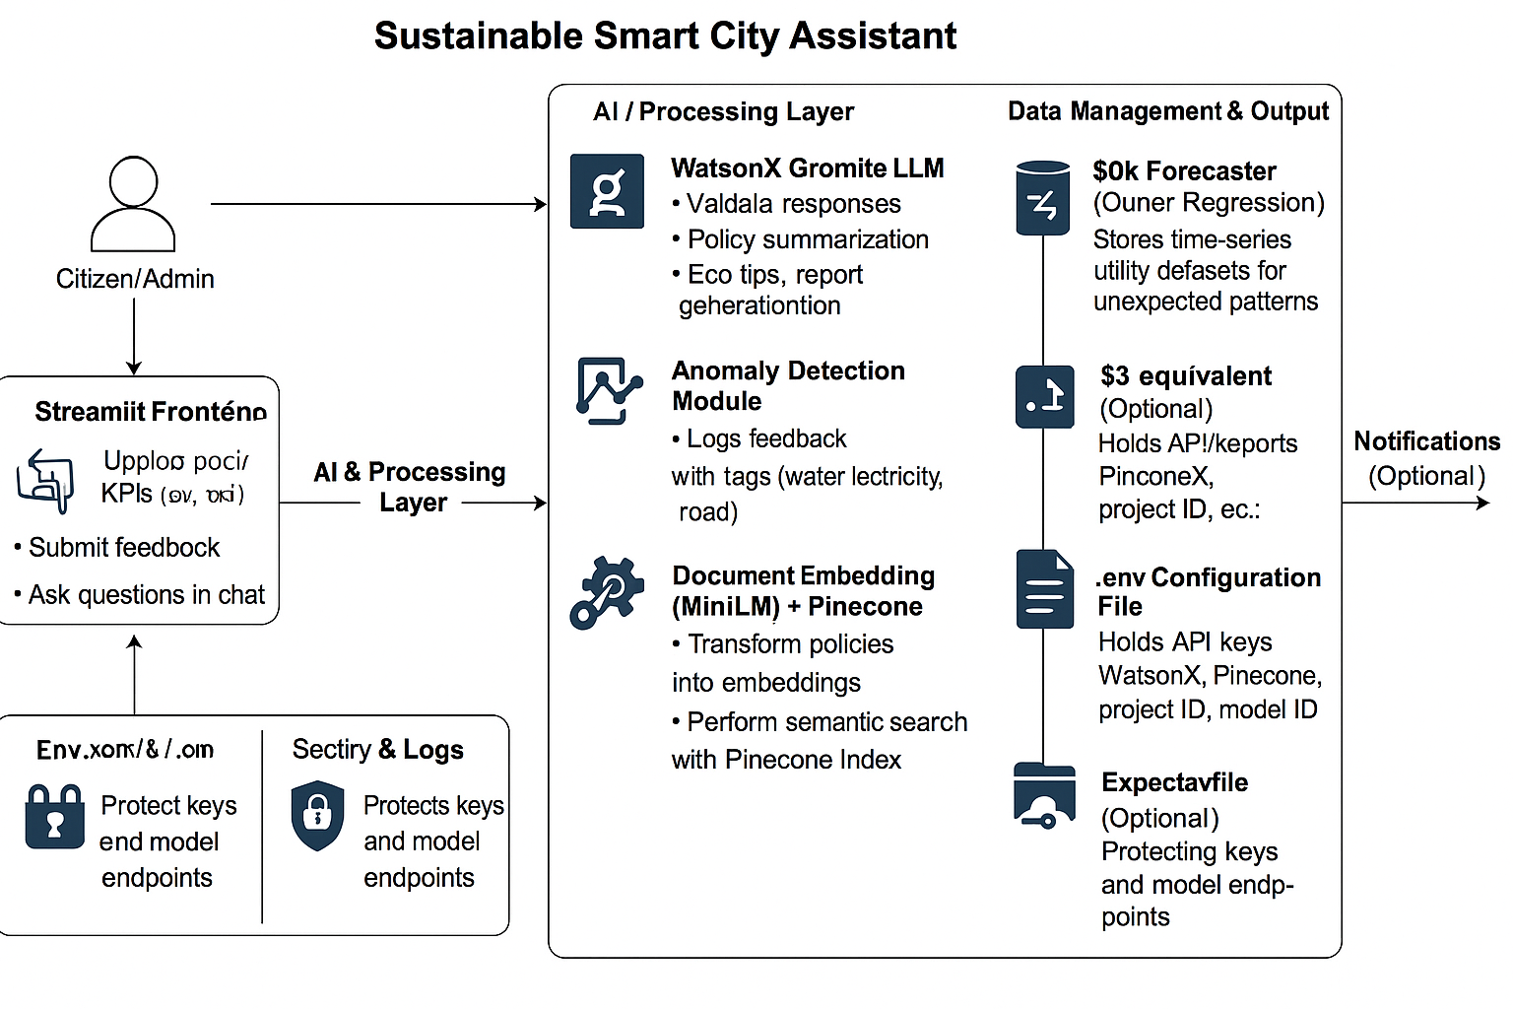

*Figure 1: Architecture and data flow of the smart city assistance.*

**Reference:** [**https://aws.amazon.com/blogs/industries/voice-applications-in-clinical-research-powered-by-ai-on-aws-part-1-architecture-and-design-considerations/**](https://aws.amazon.com/blogs/industries/voice-applications-in-clinical-research-powered-by-ai-on-aws-part-1-architecture-and-design-considerations/)